

**Proposal**

**For**

**Mobile Application**

**Bachelor of Science in Information Technology**

Project Name

**Grocery Shopping**

**Submitted by**

**Nima gyeltshen(12190068)**

**Gyalpozhing College of Information Technology**

**Table of Contents**

Description Page #

1. Project Identification 3

2. Scope, Introduction and Background of the Project 6

3. Aim and Objectives of the Project 7

4. Methodology 10

5.Project Schedule / Milestone Chart /Work plan……………………………… 14

6. Benefits of the Project (Expected output/outcomes): 15

7. Risk Analysis/Feasibility 16

8. Prototype 17

Bibliography 22

|  |  |  |  |
| --- | --- | --- | --- |
| Reference Number: | | | |
| (for office use only) | | | |
| Project Title: Grocery Shopping | | | |
|  | | | |
| Project Internal Guide: | | | |
| Name: | Mrs Sonam Wangmo | | |
| Designation: | Lecturer | | |
| Organization: | Gyalpozhing College Of Information Technology | | |
| Mobile # : | 17391134 | Tel. # : |  |
| Email: | [Sonamwangmo.gcit@rub.edu.bt](mailto:Sonamwangmo.gcit@rub.edu.bt) | | |
| **C1. Project External Guide:** | | | |
| Name: | **NA** | | |
| Designation: |  | | |
| Organization: |  | | |
| Mobile # : |  | Tel. # : |  |
| Email: |  | | |
| **C2. Student Group Lead:** | | | |
| Name: | Nima Gyeltshen | | |
| Roll No: | 12190068 | | |
| Department: | Bachelor Of Science In Information Technology | | |
| Mobile # : | 17364574 | Tel. # : |  |
| Email: | [12190068.gcit@rub.edu.bt](mailto:12190068.gcit@rub.edu.bt) | | |

|  |  |  |  |
| --- | --- | --- | --- |
| Organizations Involved in the Project: *(Please identify all affiliated organizations collaborating in the project, and describe their role/contribution to the project.)* | | | |
| **D1. Industrial Organizations:** | | | |
| *#* | *Organization Name* | | *Role / Contribution* |
|  | *NA* | |  |
| **D2. Academic Organizations:** | | | |
| *#* | *Organization Name* | *Role / Contribution* | |
|  |  |  | |
| **D3. Funding Organizations:** | | | |
| *#* | *Organization Name* | | *Role / Contribution* |
|  | *NA* | |  |
| Key Words: Grocery, Mobile application, Customer, Shopkeeper and | | | |
|  | | | |
| Research and Development Theme: | | | |
|  | | | |
| Project Status: (Please mark ☑)  ☑ New Modification to previous Project  Extension of existing project | | | |

|  |  |  |
| --- | --- | --- |
| Project Duration: | | |
| Expected Starting Date: |  | |
| Planned Duration in months: 6 months |  | |
|  |  |  |

# 2. Scope, Introduction and Background of the Project

|  |
| --- |
| Scope of the Project: Scope of the Project: To develop a grocery shopping app with following features:System Scope : **Login: -** In this module user has to login with his user id and password. After user is authenticated he/she can purchase the products.  **View product: -** User can view product by different category such as fruits, vegetables, meat, dairy product and etc.  **Payment: -** User can make payment through cash on delivery or on credit card. User Scope : Scope of the project is Gyalpozhing town. |
|  |

|  |
| --- |
| Introduction (Project Background and Literature Review, Current State of the Art): Project Background  Grocery shopping is an android application where user can buy grocery products online. Grocery Products are displayed in effective graphical user interface. This system will be like a virtual supermarket. The project objective is to deliver the grocery shopping application into android platform. Grocery shopping is the process whereby consumers directly buy goods or services from a seller in real-time, without an intermediary service, over the Internet. It is a form of electronic commerce. This project is an attempt to provide the advantages of grocery shopping to customers of a real shop. It helps buying the products in the shop anywhere through internet by using an android device. Thus the customer will get the service of online shopping and home delivery from his favorite shop  **Literature Review:**  Vijayasarathy (2004), in his research, used a sample of 281 consumers to test a model of consumer intention to use online shopping. The study found compatibility, usefulness, ease of use, and security to be significant predictors of attitude towards online shopping, but privacy was not. Another finding showed that intention to use online shopping was strongly influenced by attitude toward online shopping, normative beliefs, and self-efficacy.  Gulten Bozkurt (2010) study was based on the comparison of the consumer environmental characteristics of regular grocery shoppers who buy online from those who buy in the store. It also aimed at the food shopping habits between consumers who buy online against those who buy in the store. The results obtained in this study showed that there was no variation between the online and the physical store participants in relation to environmental characteristics when shopping for food or groceries. |
|  |

|  |
| --- |
| Challenges: **Not all Bhutanese people can access the App:** 33.5% of the population is illiterate in Bhutan. So, it will be difficult for those users to use the app.  **Developing an app without being proficient is hard:** Developing an app is not an easy task as it requires lot of knowledge as well as it should be liked by the user.  **Time constraint:** Development of an app requires lots of effort and time. As we have to complete the app within 5 months.  **Resource Availability:** Need high speed internet connection and compatible devices for the development of app. Not familiar with the software used for the development of app(Android studio). |
|  |
| Motivation and Need: Today more than ever everyone goes after solutions for saving their resources, say, money or time, managing their daily routine. Taking care of multiple housework issues could be pretty stressful, thus, advanced technologies are pleased to assist. People enjoy apps with grocery shopping features, as, when it’s necessary, such platforms are to draw up for grocery shopping to get supplies. Persons who don’t have possibilities to shop around will gladly enjoy online applications for groceries. Grocery shopping apps with delivery options shall be indispensable for those who cannot pick up what they’ve ordered from the supermarket. |
|  |

|  |
| --- |
| 1. ***Aims/Objectives*** |
| AIM : To develop a grocery shopping app.  OBJECTIVES : To make an application in android platform items in an existing shop.  A complete and efficient web application which can provide the grocery  shopping experience.  **Purpose** :  The purpose of this project is to investigate the consumers’ attitude-intention relationship regarding online grocery shopping in Gyalpozhing. It focuses on positive attitudes whether there is an influence on the consumer intentions to purchase groceries online. It is the change in purchasing pattern from going to a physical store to an online store. Therefore, it focuses on the shoppers’ intentions and adoption of whether or not to use online grocery shopping. It is believed that this research is needed and has high relevance since the online grocery market only represents 1% of the total grocery market in Gyalpozhing and this implies a low consumer adoption. This research will contribute with knowledge of positive attitudes and if they influence the intention to purchase groceries online, furthermore this will lead to a better understanding within the area of research. |
|  |
|  |

# 4. Methodology

|  |
| --- |
| Development / Research / Test Methodology: Problem statement  The current grocery shopping is critical to set up online shops, customers to browse through the shops, and a system administrator to approve and reject requests for new shops and maintain lists of shop categories. This is a small-scale project for grocery shopping system. The basic idea is that the candidates can buy product from anywhere during any time. The database will maintain the product details information. Customer can view their product details. This grocery shopping involves with two types of users.   * Customer * Shopkeeper   Customer Role:  The customers can login to the system. He/ She can view his/her product details and buy their product. The customer can just view the information whereas he/she could not make changes in the database.  Shopkeeper Role:  The shopkeeper plays a vital role in the grocery shopping. The shopkeeper controls the entire database. The report of the product is generated by the shopkeeper itself. The main role of the shopkeeper is to safeguard the database and can add/delete the products from the database.  https://documents.lucid.app/documents/09de1f8e-f519-43bc-8cb8-de79677a9a3d/pages/0_0?a=1694&x=-5&y=-65&w=1870&h=1430&store=1&accept=image%2F*&auth=LCA%20a746c03ee4ee18c54579bbe1810cdb680998b824-ts%3D1614319590  **Literature Review/ Problem Gathering**- Literature Review is done to get the help and clear concept about the project. I have gone through some related app or websites that is related to Project topic. We have collected the drawbacks faced by the current grocery app.  **Requirement Gathering** – Collecting all the required information regarding the development of App through Survey, brainstorming and collecting information from the internet.I will design the user-interface design, Database design and finally the system design.  **Designing and Development –** Designing of the app from the information collected from the requirement gathering and analysis and codebase to develop the app.  **Testing phase –** Once app is developed, it needs to be tested for the every development of features for the bugs and errors.  **Documentation –** The final phase is for documenting all the necessary things that are being done in the process of the development of the app. Documentation is necessary for the sole purpose of educating third parties and the users. |
| **Agile Model**  Agile methodology is a collection of innovative, user-centered approaches to system development. It tries to define an overall system plan quickly, develop and release software quickly, and then continuously revise the software to add additional features. Where Agile method breaks task into smaller iteration or parts. It isn’t a set of tools or a single methodology, but a philosophy of people who had realized that in software development it’s pretty hard to predict   1. The number of changes and priority changes in software requirements. 2. How much design is needed before construction is used to prove it. 3. The time for analysis, design, construction and testing.   Agile model plans regarding the number of iterations the duration and the scope of each iteration are clearly defined in advance. Agile development methodology is a conceptual framework for undertaking any software engineering project.  Needs of Agile Model   * Customer satisfaction * Continuous delivery of useful software. * People and interactions are emphasized rather than process and tools. * Customers, developers and testers constantly interact with each other. * Working software is delivered frequently. * Risk is reduced. |

|  |
| --- |
| Project Activities: *(Please list and describe the main project activities, including those associated with the transfer of the research results to customers/beneficiaries. The timing and duration of research activities are to be shown in the Gantt chart in Section 8.)*   1. Installation of required software for development process:  * Android Studio  1. Feasibility study: Survey will be done for shopkeeper separately to check the feasibility for the project. 2. Software Design: in this phase, it includes designing user interface, database design and familiarizing the functionalities that will be added while developing the app. 3. Coding and development of app: In this phase designing is done from the information obtained from the requirement gathering and requirement specification and at the same time developing the app by keeping the design concept in mind 4. Testing: in this phase once the app has been developed, it needs to be tested for identifying any bugs and errors. 5. Documentation: Documenting all the necessary things that are being done in the process of the developing of the app. Documentation is necessary for the sole purpose of educating third parties and users. |
|  |

|  |  |  |  |
| --- | --- | --- | --- |
| Key Milestones and Deliverables: *(Please list and describe the principal milestones and associated deliverables of the project. A key milestone is reached when a significant phase in the project is concluded, e.g. selection and simulation of algorithms, completion of architectural design and design documents, commissioning of equipment, completion of test, etc.) The timing of milestones is also to be shown in the Gantt chart in Section 8.* | | | |
|  | | | |
| *No.* | *Elapsed time from start (in months) of the project* | *Milestone* | *Deliverables* |
| 1. | 09/02/2021to  20/02/2021 | *Topic Selection* | Selected the topic for mobile app development |
| 2. | 21/02/2021 to  01/03/2021 | Content gathering | Collected the required information. |
| 3. | 02/02/2021 to  14/03/2021 | Project proposal | Submission of proposal |
| 4. | 15/03/2021 to  20/03/2021 | Requirement gathering and Analysis | Software requirement specification document(SRS) |
| 5. | 20/03/2021 to  26/03/2021 | Design | Erd-design,  relational diagram,database design,  user-interface design, architectural design. |
| 6. | 28/03/2021 to  30/04/2021 | Coding and implementation | Implementing of functional features and source code |
| 7. | 01/05/2021 to  09/05/2021 | Testing | Test case |
| 8. | 10/05/2021to  16/05/2021 | Completion of development | Completing the development of the application |
| 9. | 17/05/2021 to  22/05/2021 | Final document | Presentation of final work progress |
|  |  |  |  |
|  |  |  |  |
|  |  |  |  |
|  |  |  |  |
| (Please add more rows if required.) | | | |

# 5. Benefits of the Project (Expected output/outcomes):

|  |
| --- |
| The outcomes of the project would be fully functional School Notice APP with the following features:  1 . Time savvy  2 . Customized shopping  3 . Multiple payment options  4 . Cost-effective |
|  |
|  |

|  |
| --- |
|  |
|  |
|  |

|  |
| --- |
| Risks of the Project: (Please describe the factors that may cause delays in, or prevent implementation of, the project as proposed above; estimate the degree of risk.)  (Please mark ☑ where applicable) Low Medium High  Technical risk ☑  Timing risk ☑  Budget risk ☑ |
| A1. Comments(Describe the risk):Technical risk: As the development of the app begins, the lack of knowledge may become a hinder in the development.Timing risk: The risk of whether the project will be completed on time or not will be also another risk as the development begins.Budget risk: Since the project does not require any financial need, the risk of budget is not concern. |
|  |
|  |

# 10. Project Schedule / Milestone Chart /Work plan

Prototype

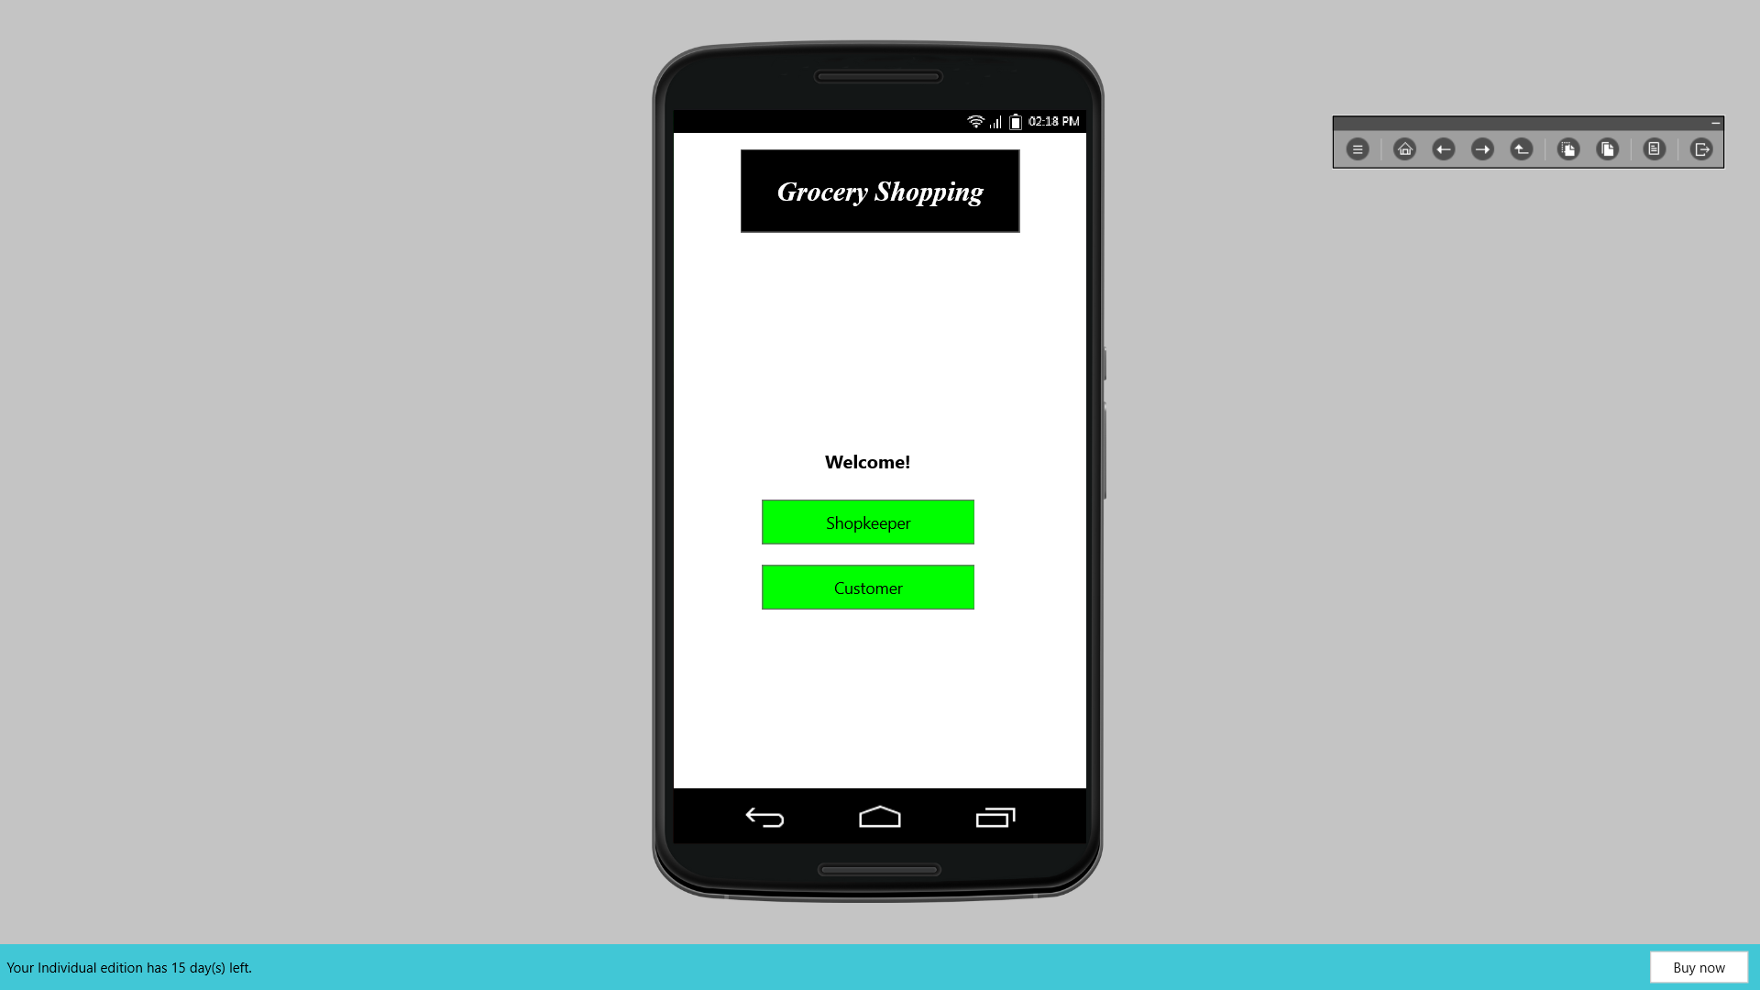 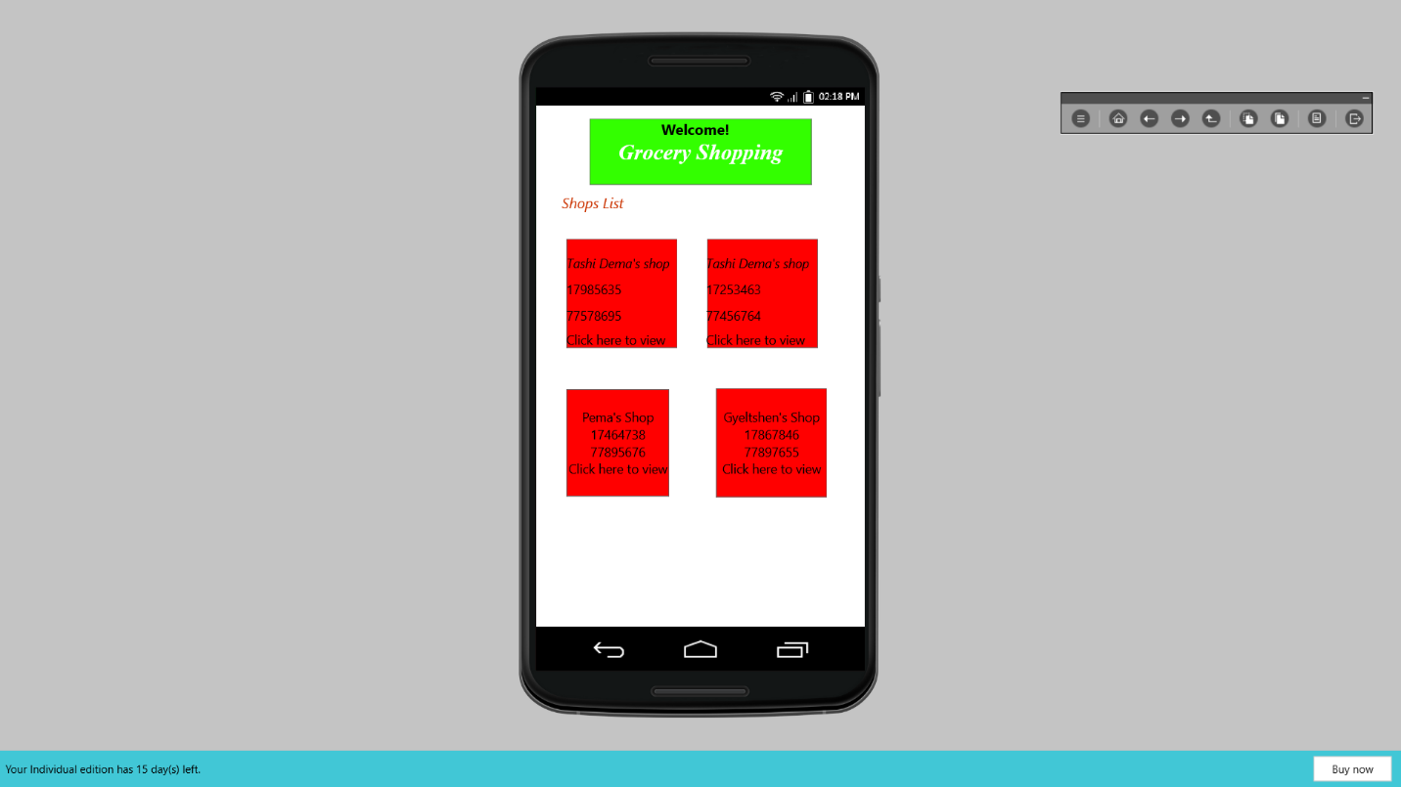

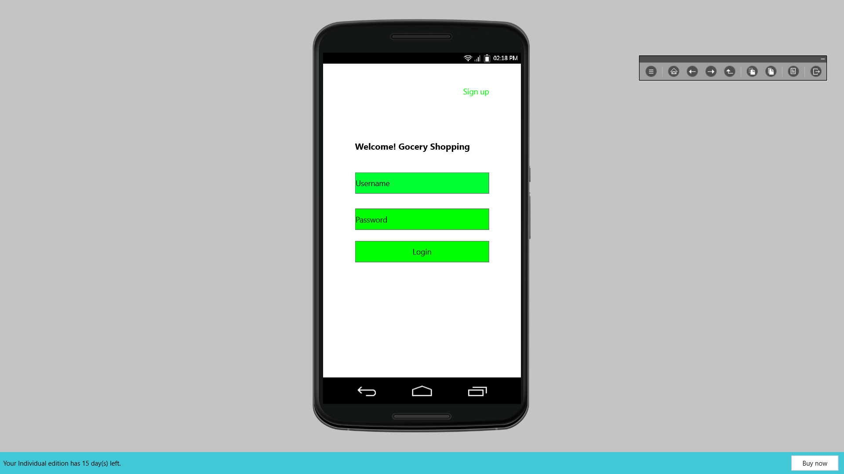 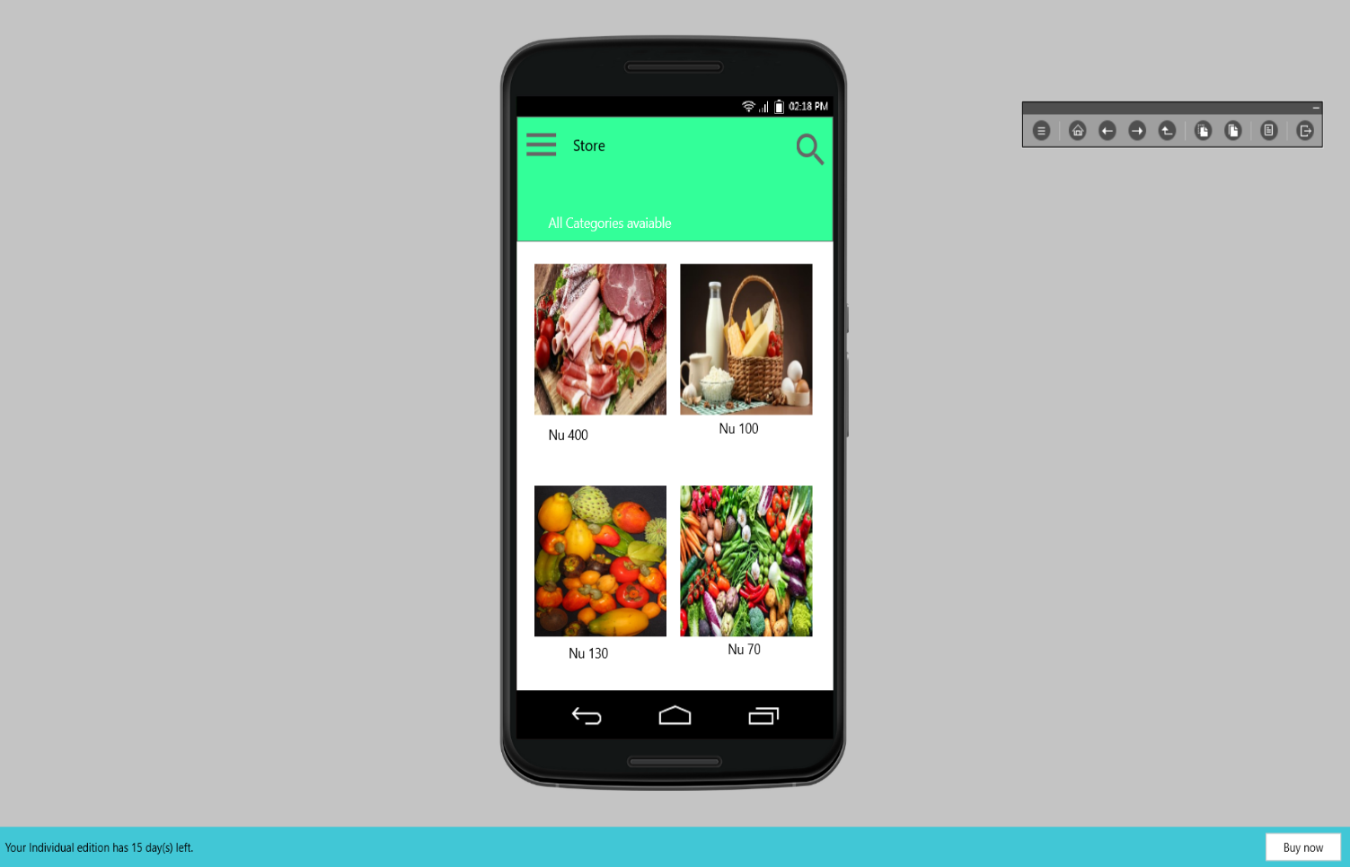

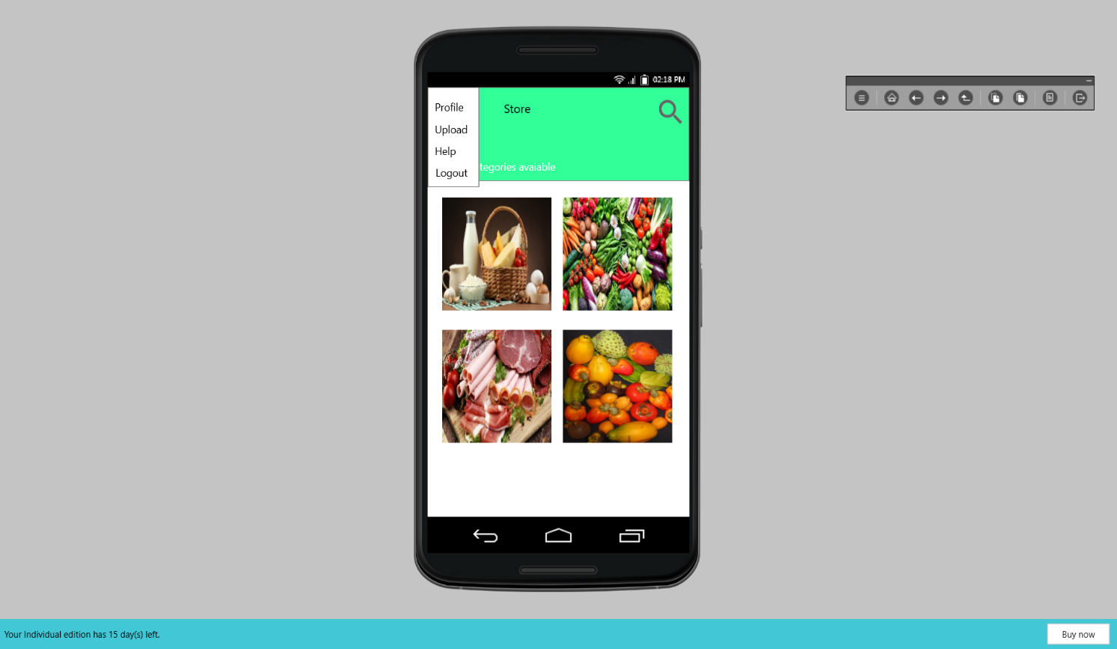 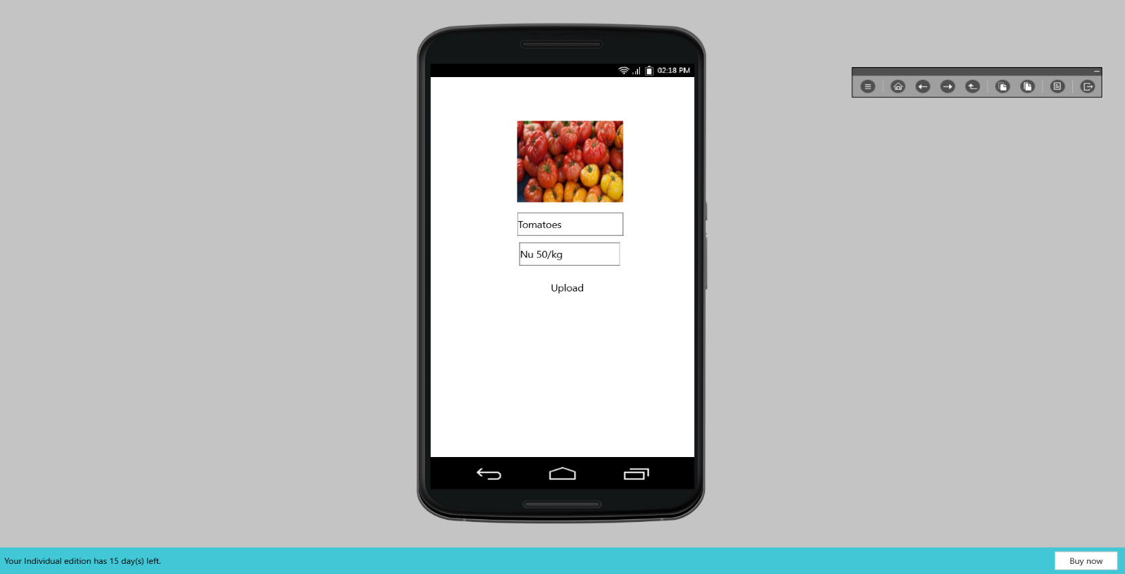

**Working**

The system after careful analysis has been identified to be presented with the following modules and roles.

The modules involved are:

- Shopkeeper

- User

Shopkeeper:

The shopkeeper has all the information about all the users and about all products.

This module is divided into different sub-modules.

**1 . Manage products**

**Add Products**

The products can be classified into different categories by name. Shopkeeper can add new products into the existing system with all its details including an image.

**Delete Products**

Shopkeeper can delete the products based on the stock of that particular product.

**2 . Manage Orders**

**View Order**

Shopkeeper can view the orders which is generated by the users. He\she can verify the details of the purchase.

**Delete order**

Shopkeeper can delete order from the orders list when the product is taken for delivery.

**USERS**

A new user will have to register in the system by providing essential details in order to view the products in the system.

**Login**

A user must login with his user name and password to the system after registration.

**View Products**

User can view the list of products based on their names after successful login. A detailed description of a particular product with product name, products details, product image, price can be viewed by users.

**Search Product**

Users can search for a particular product in the list by name.

**USER**

* **USER LOGIN**

**Description of feature**

This feature used by the user to login into system. A user must login with his user name and password to the system after registration. If they are invalid, the user not allowed to enter the system.

**Functional requirement**

* Username and password will be provided after user registration is confirmed.
* Password should be hidden from others while typing it in the field
* **REGISTER NEW USER**

Description of feature

A new user will have to register in the system by providing essential details in order to view the products in the system.

* **PURCHASING AN ITEM**

- System must ensure that, only a registered customer can purchase items.

**SHOPKEEPER**

* **MANAGE PRODUCTS**

**Description of feature**

The shopkeeper can add product, delete product and view product.

* **MANAGE ORDERS**

**Description of feature**

The shopkeeper can view orders and delete orders.

**Functional requirements**

-The system must identify the login of the shopkeeper.

# Bibliography

Amol Ranadive, An Empirical Study on the Online Grocery Shopping Intentions of Consumers

in Vadodara City, International Journal of Management and Social Sciences Research (IJMSSR) ISSN: 2319-4421 Volume 4, No. 3, March 2015

<https://www.concettolabs.com/blog/grocery-app-development-benefits-buyers-retailers/>

Vijayasarathi. R, Predicting consumer intentions to use online shopping: the case for an

augmented technology acceptance model, in journal of information and management volume 41 issue 6, July 2004